Ola Adesina

9/10/ 2023 DEVOPS ENTRY LEVEL

A

Virtual box act like an operating system (OS). VB makes the OS works as if it's running in actual hardware.

Running an OS in your laptop will make it run slow. It's better you run Ubuntu as a separate OS.

VirtualBox can run a guest operating system in a window of the host operating system without giving it direct access to your computer's hardware.

- VirtualBox can run all versions of Windows. Although some versions of Linux (including Ubuntu) exist that are optimized to run as a guest OS in a virtual environment.

1. Concept of Terminal in Linux and GUI

a. The Linux command line has a high ground when it comes to performance, control, and ease of use

i.e using cli to create multiple files

mkdir ola john mike / touch ola john mike

**Result:** 3 directories/files would be created

ola directory / ola file created

john directory / john file created

Mike directory / Mike file created

Moreover, the GUI has limited options that are available in the command-line application.

b. Quick of navigation in using CLI, although it might be very challenging for new users . Command can be re-used using upper arrow and easy and faster with time due to many options compare to using GUI.

d. In most of the open-source projects, the developers usually first provide command-line access to their applications, before/ later provide GUI support.

e.

2. LS command – We us ls command to print a “long listing”, which includes extra details such as permissions, ownership, file sizes, and timestamps

Ls can be use as stand alone or with options/arguments

Ls without option/argument:



Ls with option

Ls -1

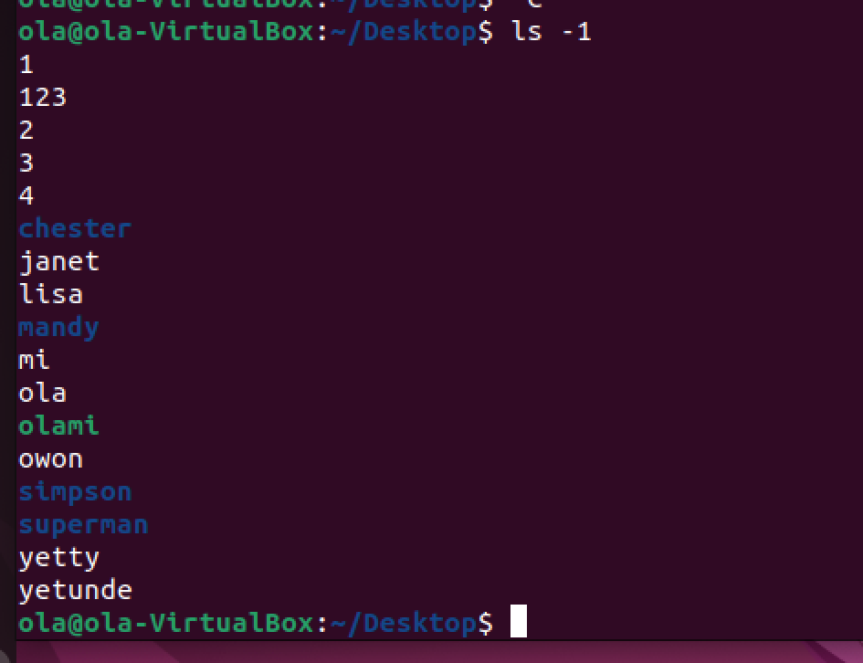

Ls -a



3. Echo can be used to output text in a file

Example:

echo “name is Ola” – txt

* Redirect file(>) – Appending text in a file

Command: echo “ola is my name”>olami

Next we can use CAT command to see what is the file as demonstrated below:

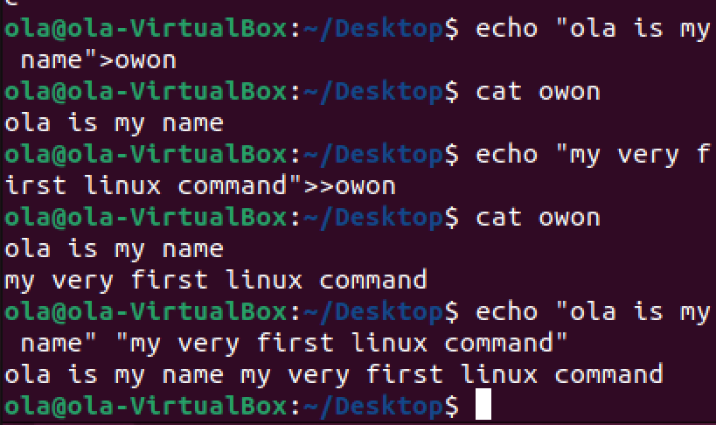

After appending without using double redirect (>>)

* Double REDIRECT/OUTPUT to view text saved in the text:

“>>”

Overwriting text: when redirect is used when there is an existing text in the file as illustrated below:

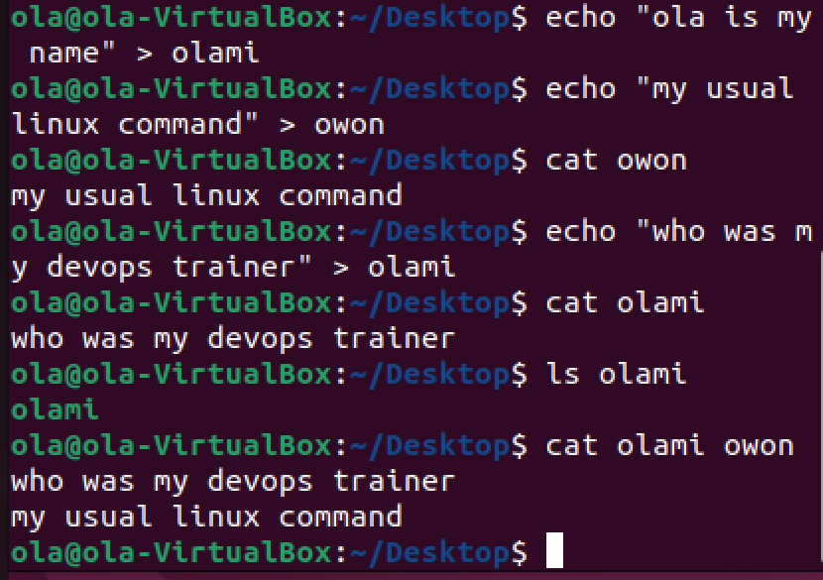

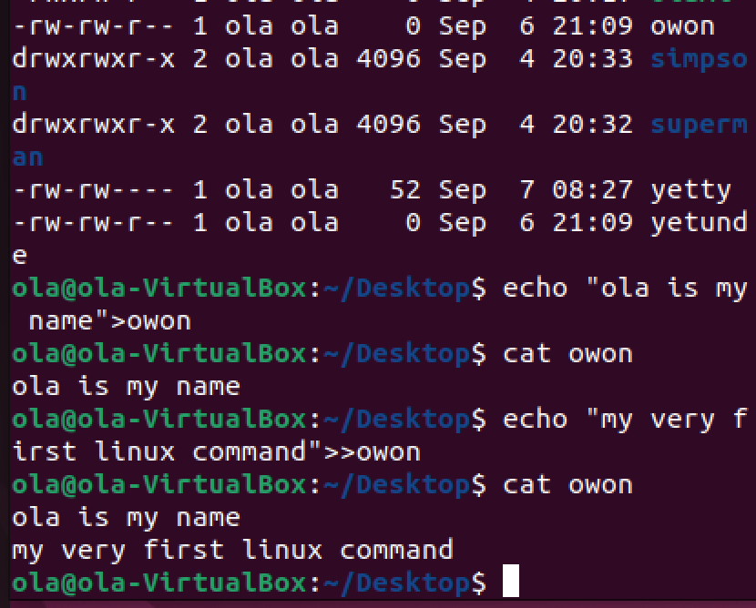

4. Differences btw “cp”, “rm”, “mv” – these are file maintenance commands

:

“cp” – command used to copy a file

“rm” – used to remove files / “mkdir – make directory

“mv” - Move the location of a file/rename a file / “mkdir - remove directory

1. “cp”

Command:

Cp yetty superw – copy yetty file and name it superw

echo

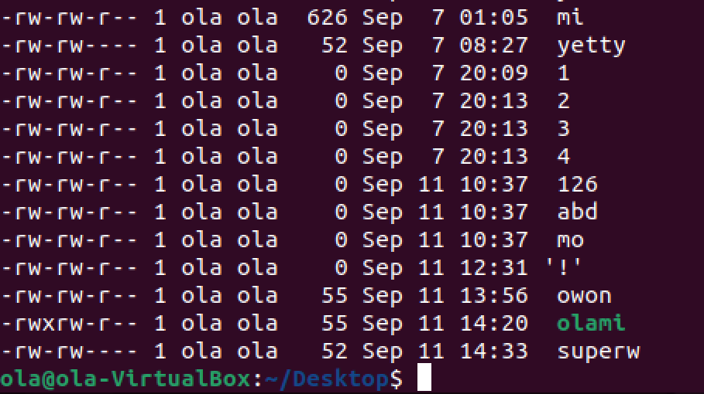

“rm” – used to remove files

Create file:

touch devops file

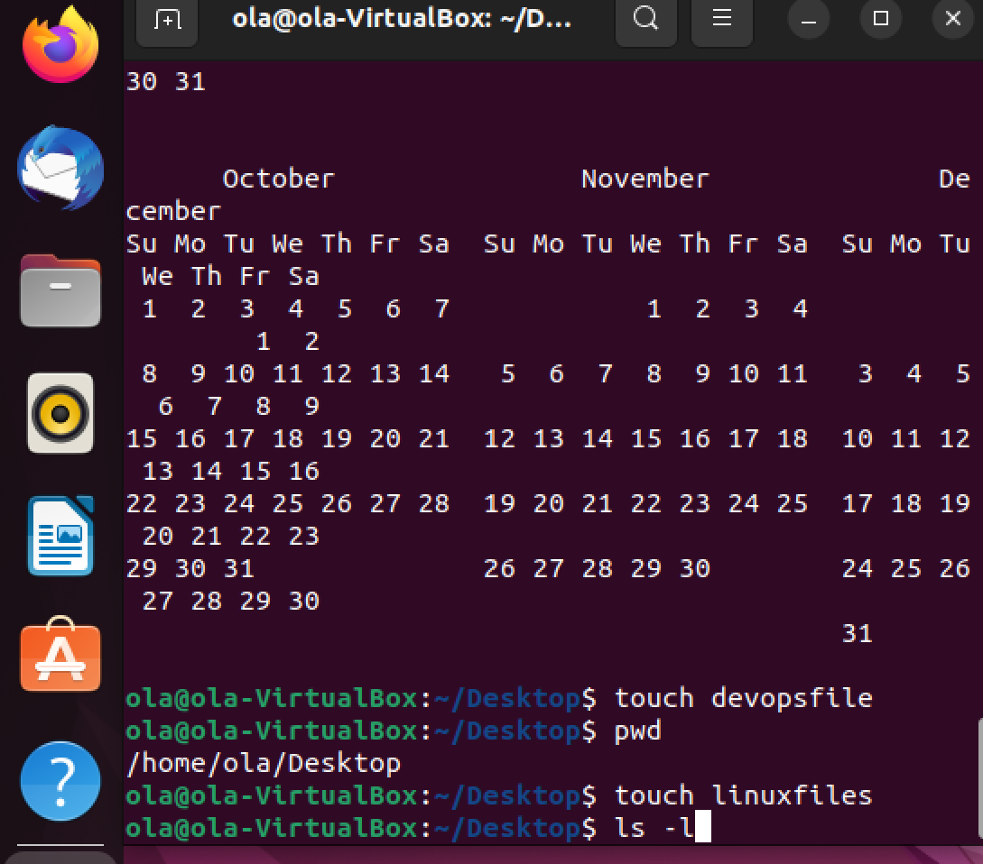

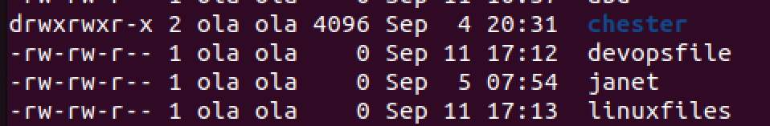

touch devopsfile

touch linux files

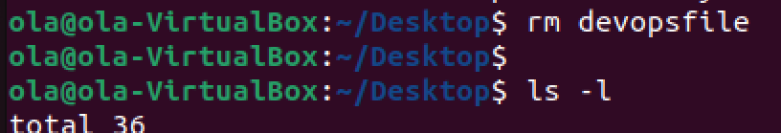

The next screen shot shows devopsfile removed. Also confirmed by re-running the command rm again on the terminal

Mv command move a file from one location to another and also can rename the file

Exp:

ls -l linuxfiles

$mv linuxfiles

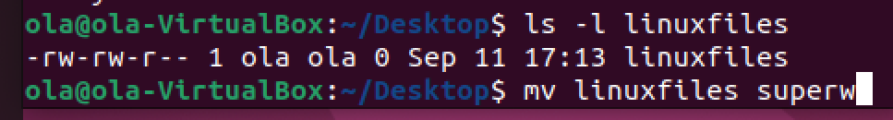

Here we rename the file “linuxfiles” – “superw” below:

